
National Textile University
Department of Computer Science
Subject:
Mobile application and development
Submitted To:
Sir Rehan Sarwar
Submitted By:
Noor ul Ain
Registration No:
23-NTU-CS-1221
Lab no:
2
Semester:
6th

Task 1:
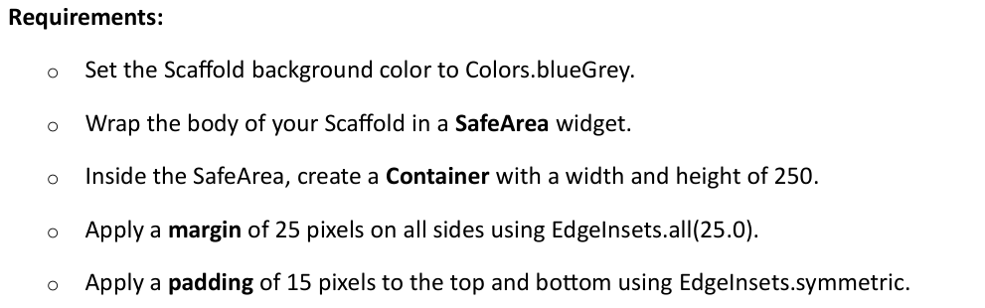

Code:
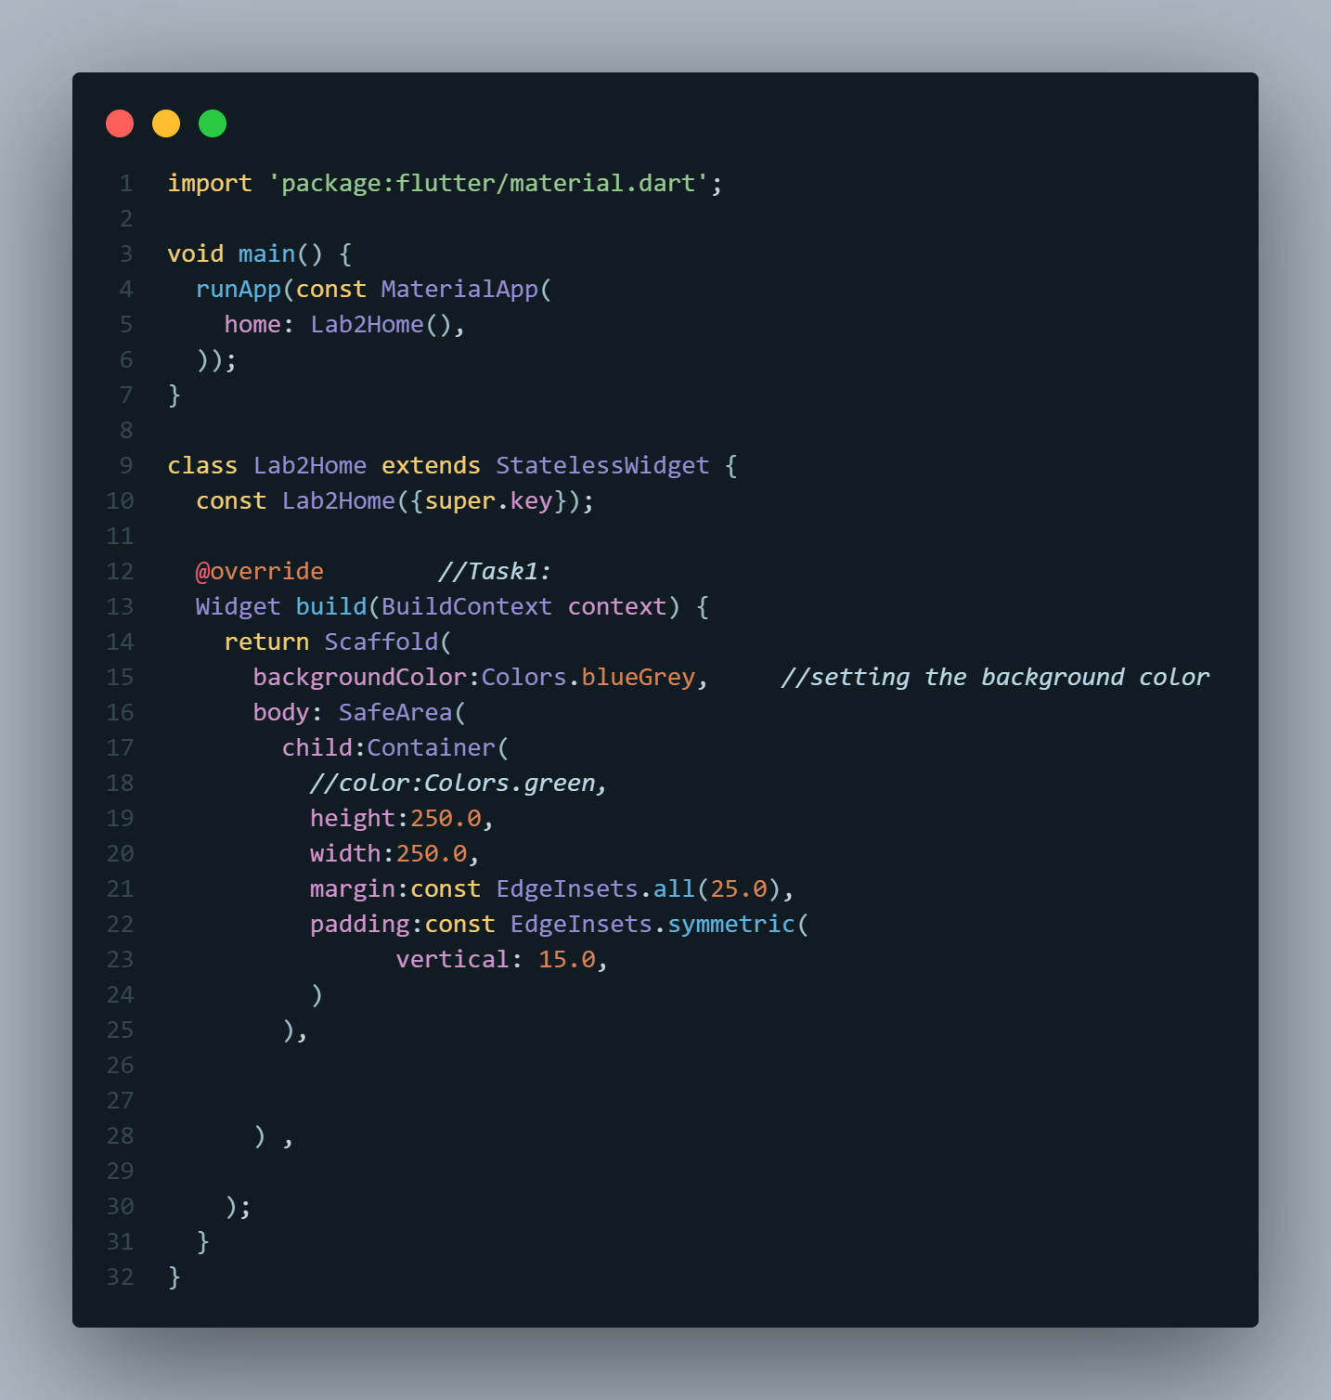
Output:
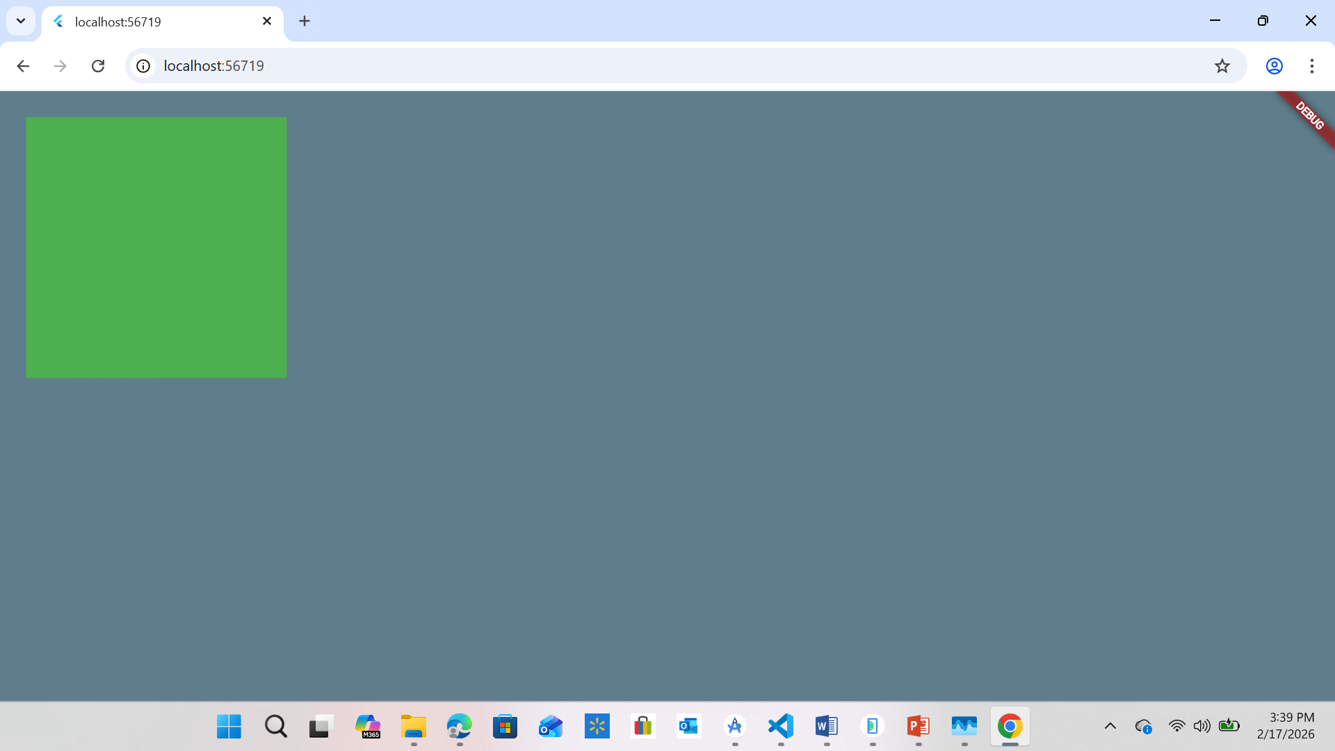
Discussion:
SafeArea is essential for modern smartphones because of physical intrusions like notches, sensor housings, and rounded corners, as well as software overlays like the status bar or the iOS home indicator. Without SafeArea, your widgets (like your Task 1 green container) might be partially covered by the clock or the camera cutout, making the app look unpolished and potentially hiding important UI elements.

Task 2:
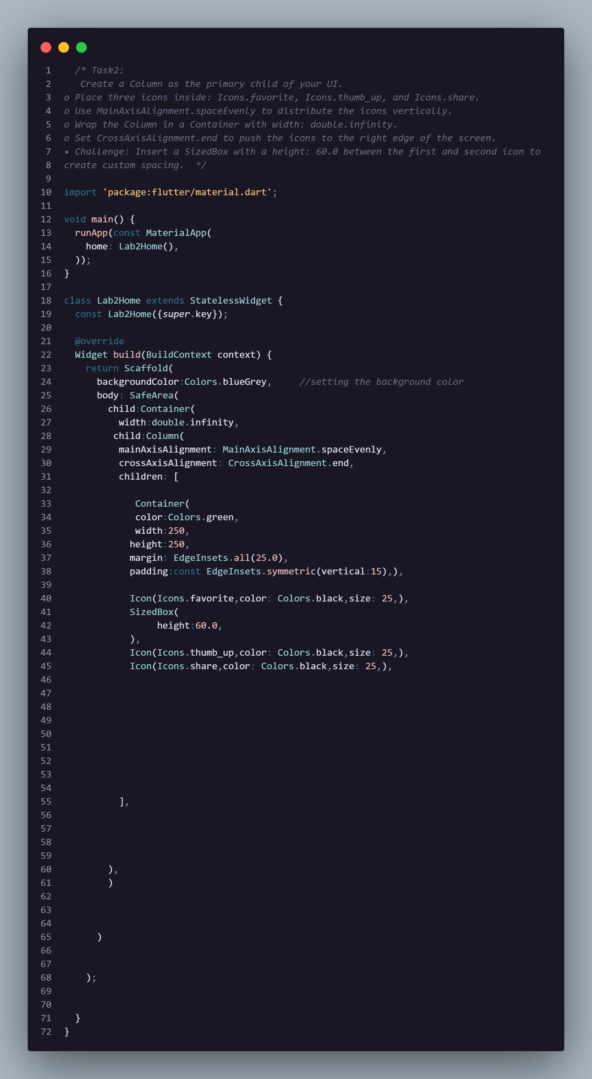

Output:
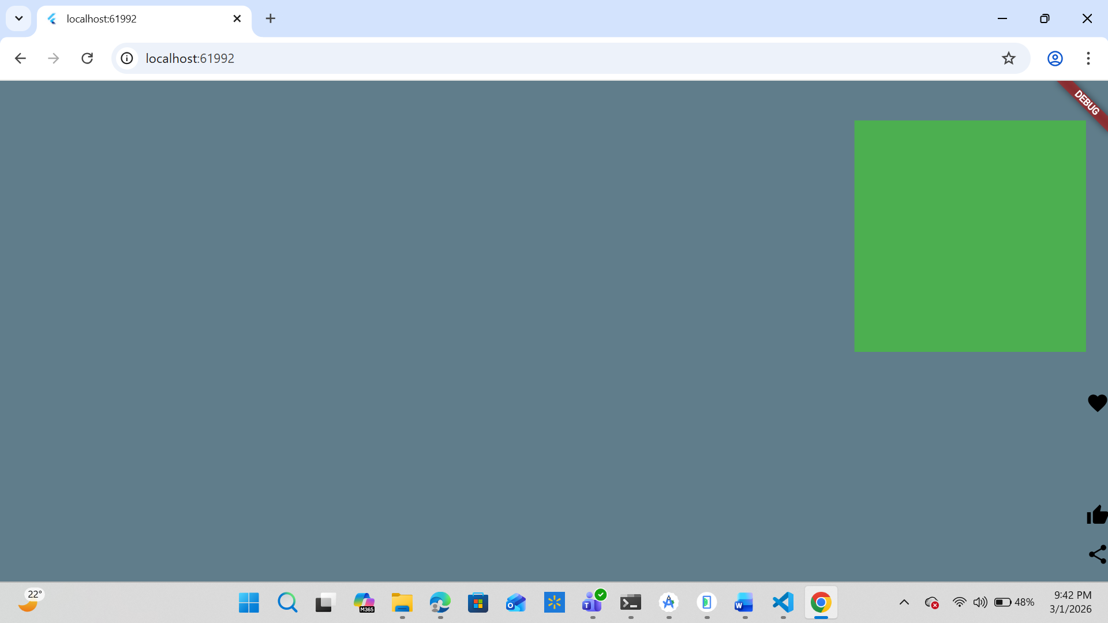

Task 3:
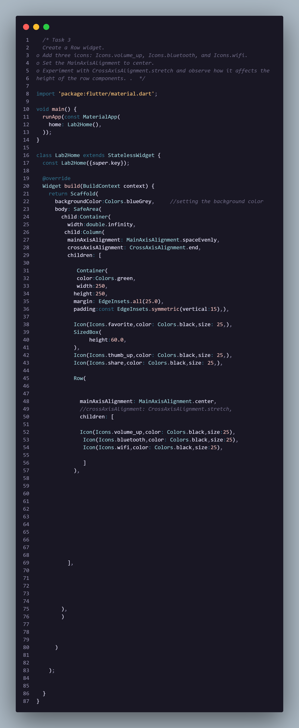

Output:
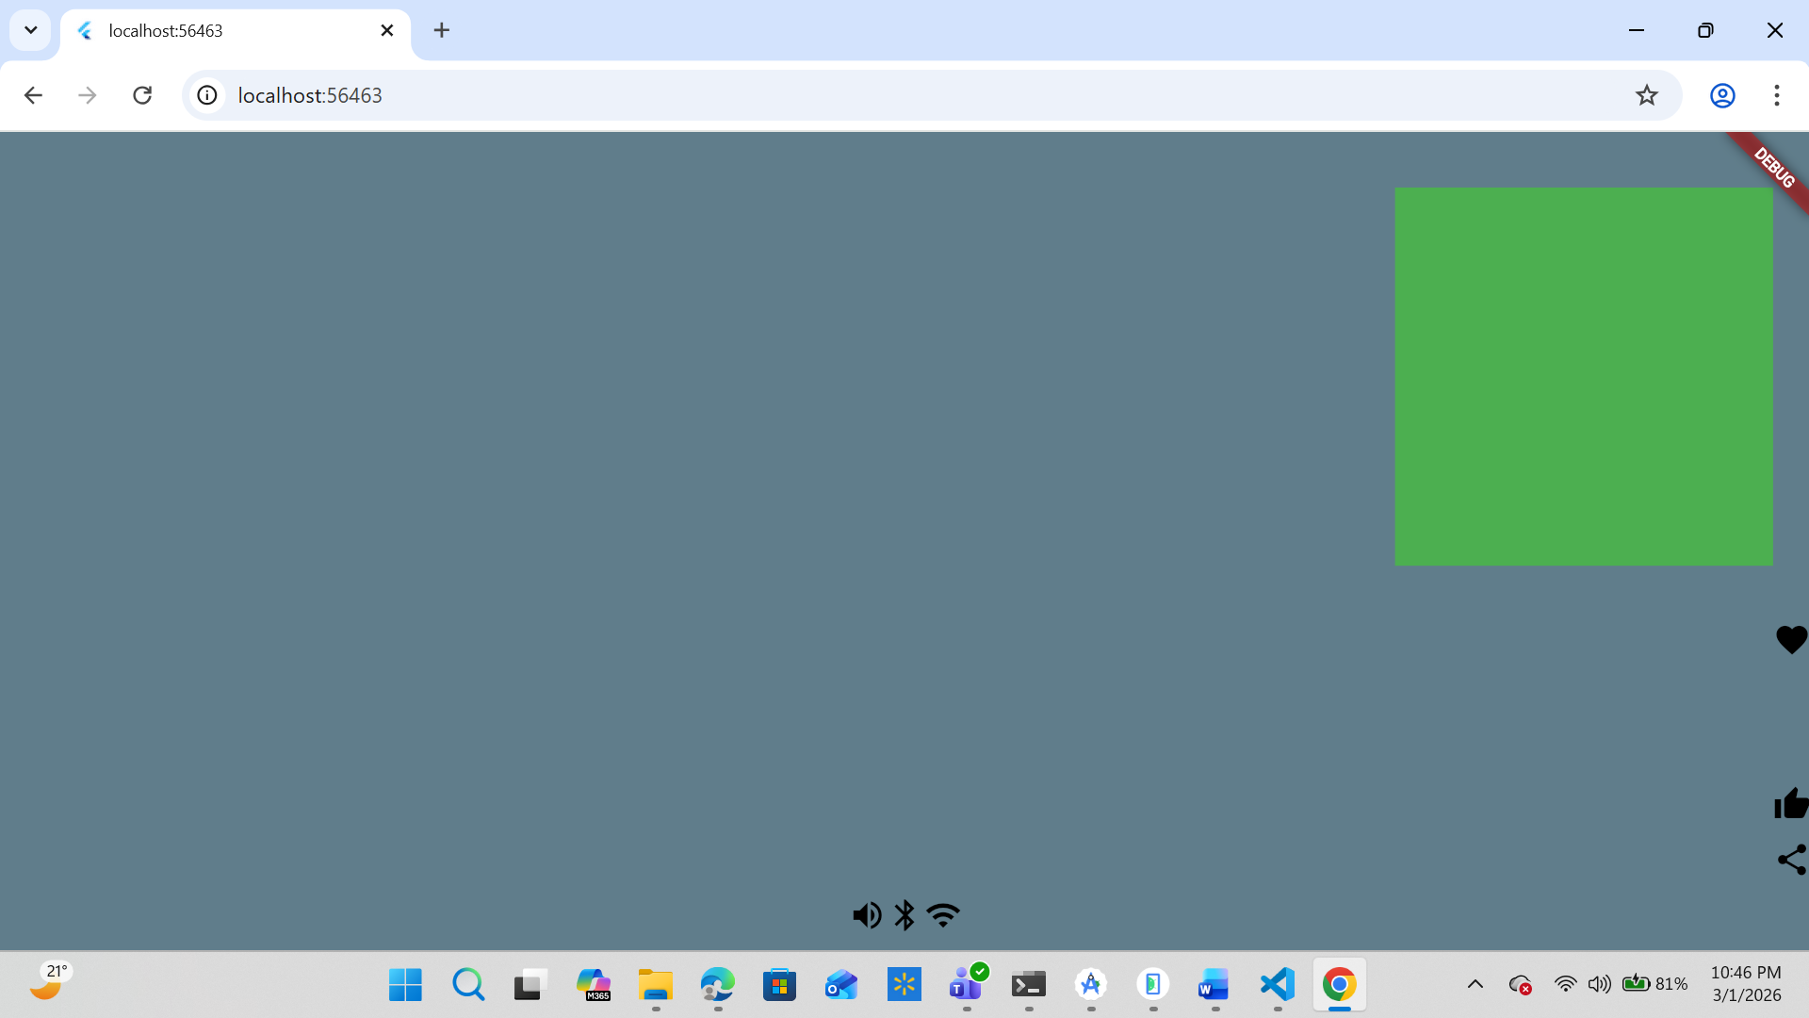

Task 4:
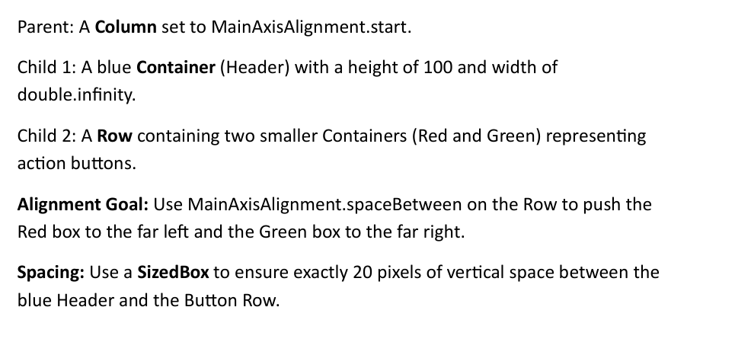

Code:
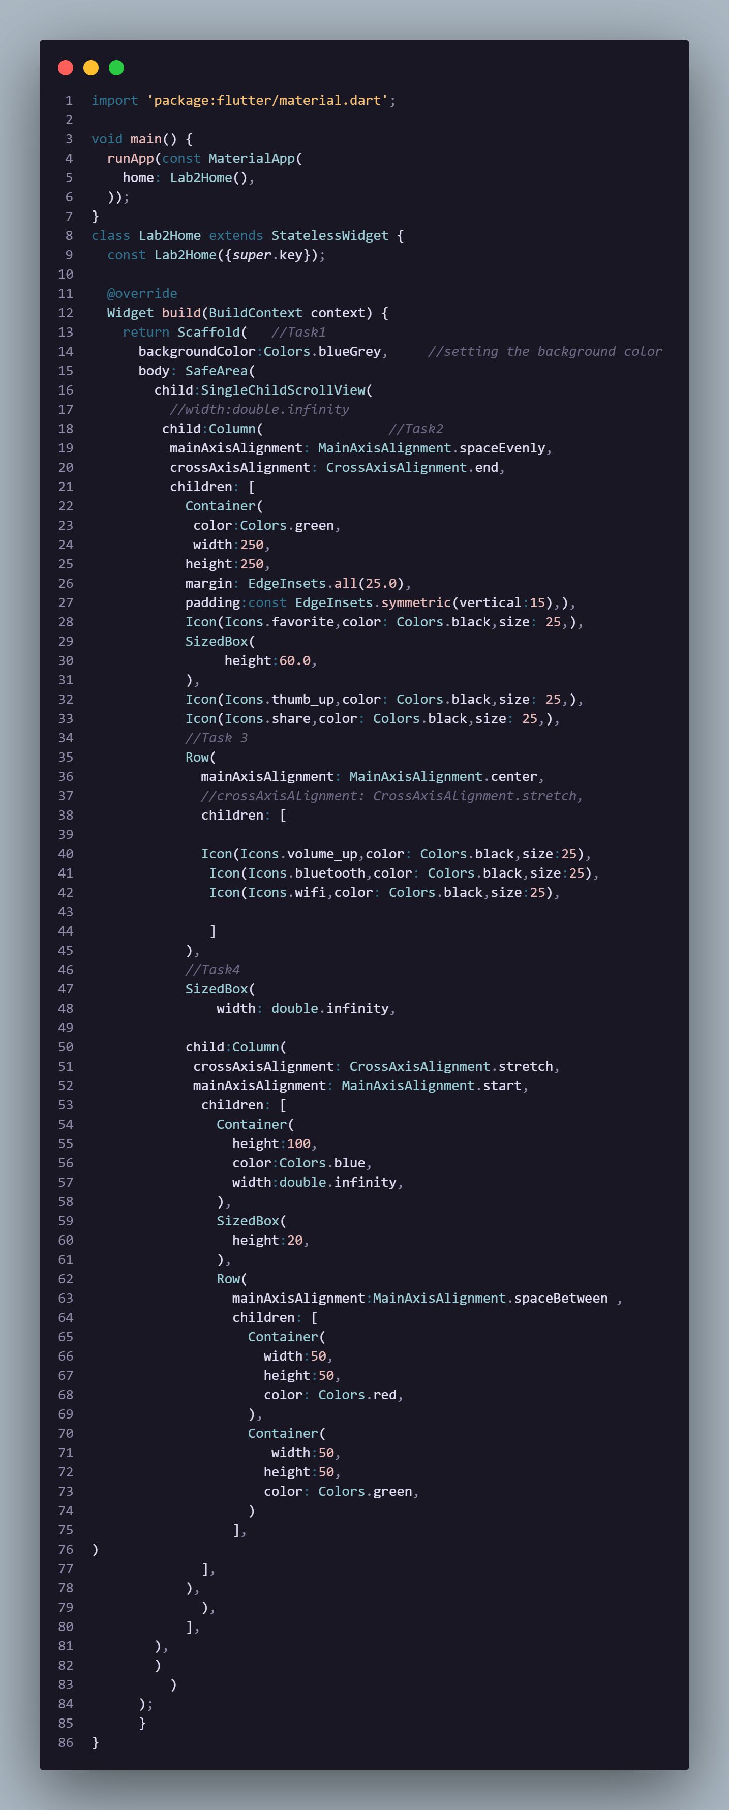

Output:
